

**North East University Bangladesh**

**Education with Innovation**

**Este: 2012**

**Team name : Ekta-Naam**

**Project name : Bangla Event Calender**

**Supervisor :**

**Noushad Sojib**

**Lecturer**

**Department of CSE**

**North East University Bangladesh**

**Submitted BY :**

**MD.Gulam Kibria Chowdhury**

ID No :- 170103020033

**Tania Sultana Mou**

ID No :- 170103020005

**Kutub Uddin**

ID No :- 170103020005 **North East University Bangladesh**

**SUBMITION DATE :- Sunday, 23 December 2018**



***Project Report***

***Project Name: Bangla Event Calendar***

***Objectives:***

***To know the English & Bangla date & year , valuable information of those dates & also know the current date & time of Bangla event calendar.***

***Tools & Technology:***

***Net-Beans***

**Theory & Descripton:**

The server side processing will be developed using java(Net-beans).First of all we’ll see welcome page in our project. When we open our welcome page we’ll see three important part in our calendar. This calendar basically stand up of those,like as

1. Choose Date
2. Choose Event
3. Add Event.

In every page this calendar will show current date & time.

**Procedure:**

In welcome page we’ll see three parts. In first part,

1.**Choose Date:**

You will give any date as you wish, within 1000-5000 .If you give any date you can see information and the day. In this, it is JCalendar. First stage we’ll see current date, when we input our choosing date then press “Ok” button, & then press “Enter” we’ll see bangla date, year & valuable information. If our choosen date has no valuable information then our calendar will give a message that’s like “This day is normal day(No event in this date). If we can’t input new date but press the ok button then our calendar will give another message, that like “Plz Entry your date”. In this page we’’ll give three options(Home, Enter,Clear). If we press “Home” button then we can back our welcome page. After choose any date then we can press “Enter” button. Even if we’ll input any date but sometimes we want to change selecting date then we press “Clear” button.

2.**ChooseEvent:**

In our welcome page, it’s our second part. We have already made Choose Event Button option. If we’ll click choose event button option then we can see Date with (bangla & English) & information List with valuable information. From list we can select date as any one we can wish and we’ll be see information on that date, and the starting year of that date and month & year. In project we’ve made search option by using JSwing. By using search option you can get about your choosing date & information. In this, it is JTable.

3.**Add date & Information**:

If you want, you can add any date & information in the list.

**Project Outcome:**

Our project have some features. As example as:

1. We can get valuable information easily from selected date.

2. Besides English date we’ll also know Bangla date.

3. As if our nationalism is Bengali we should know the important day of our country & Bengali culture. Using our calendar we’ll know these easily.

4. Many foreigner are interested to know our culture, history. They will easily satisfied their want to use our project.

5. Many foreign company are eagerly wait to work & help our country. If they know our cultural history, they’ll gain idea about our people. To use this project, they can get information.

This project is very useful for us.

**\*\*\*(welcome)**

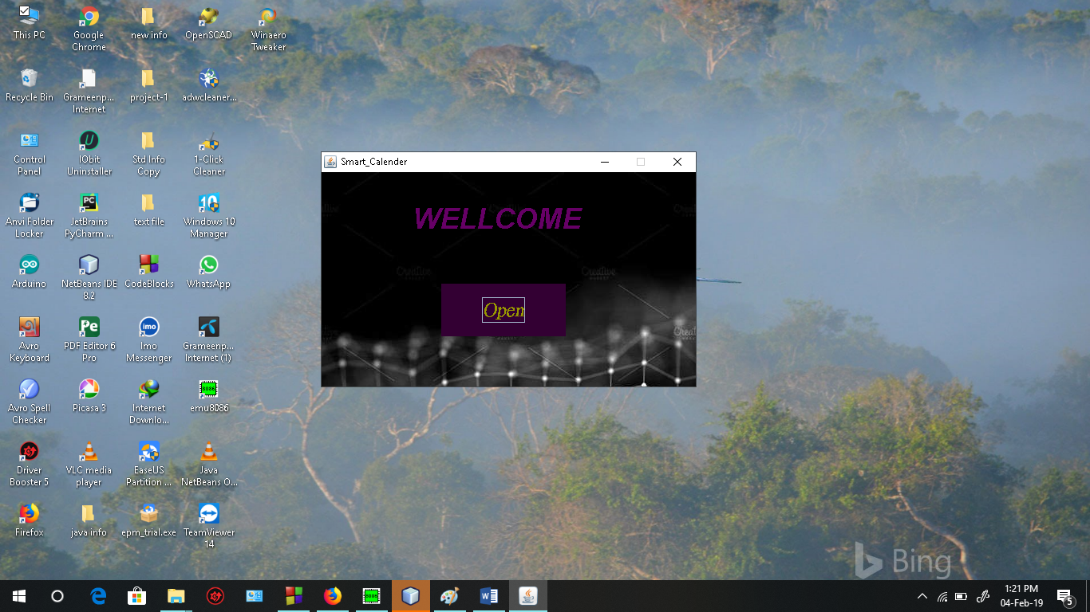

**\*\*\*( welcome/Home)**

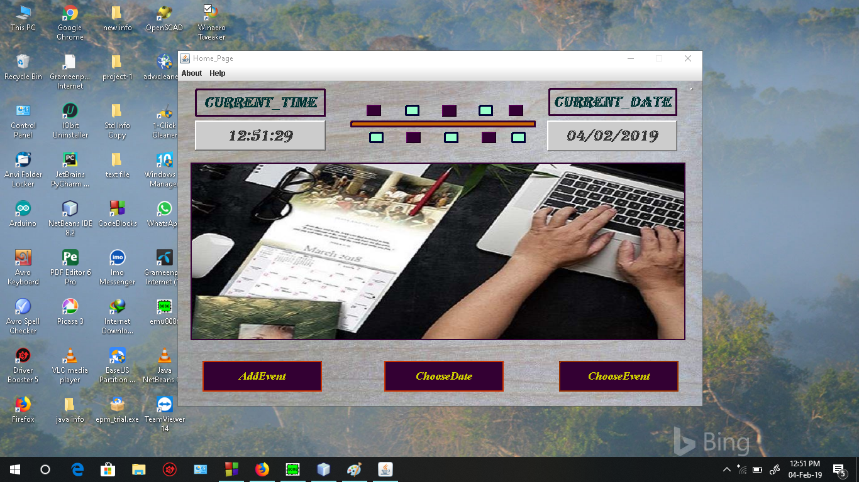

**\*\*\*( welcome/Home/choose Date)**

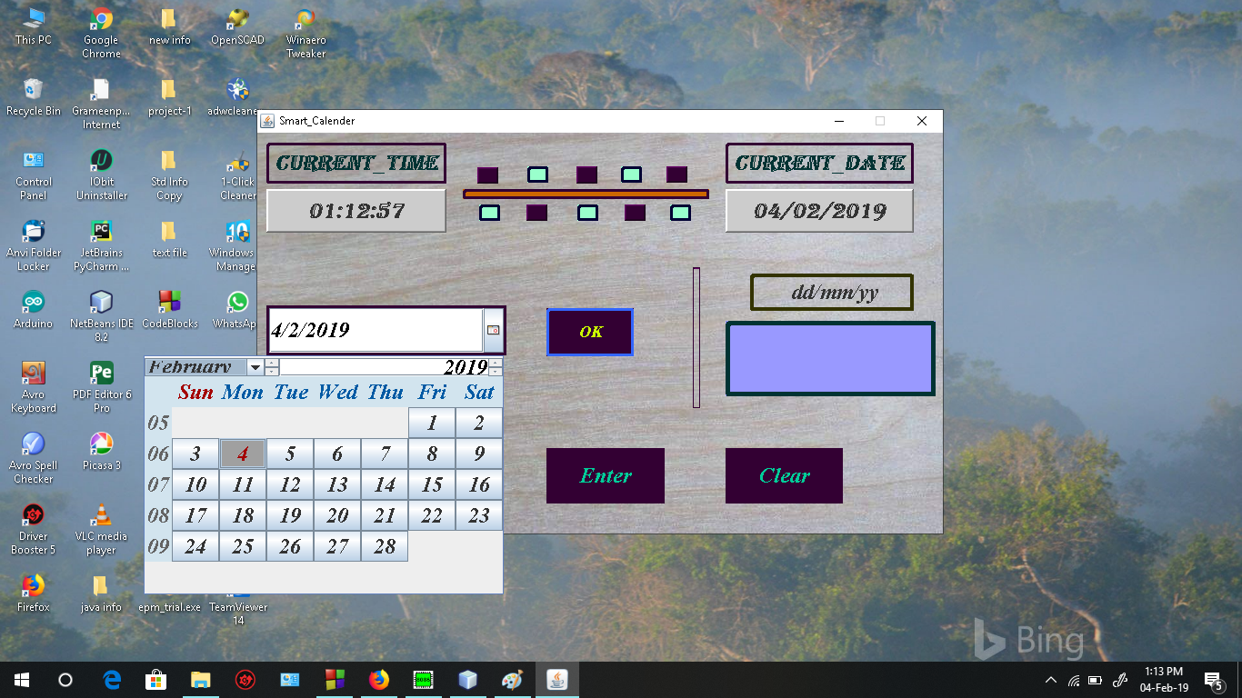

**\*\*\*( welcome/Home/choose Date/output)**

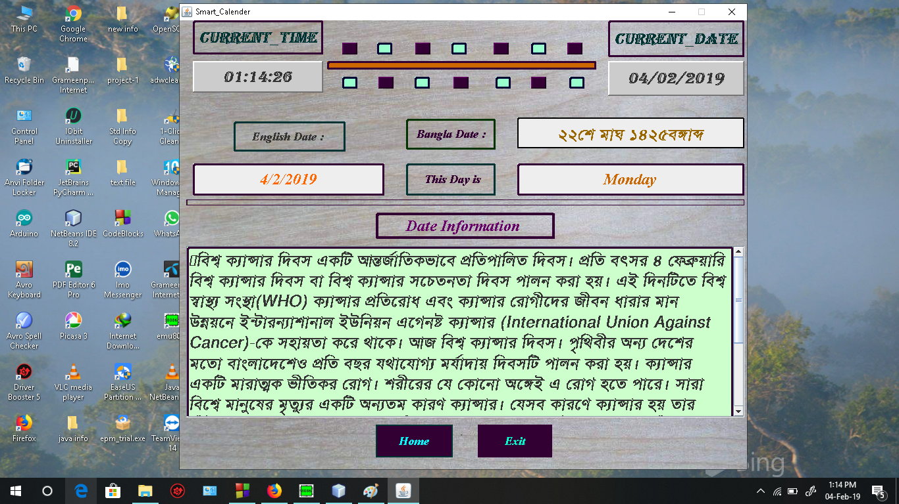

**\*\*\*( welcome/Home/choose Event)**

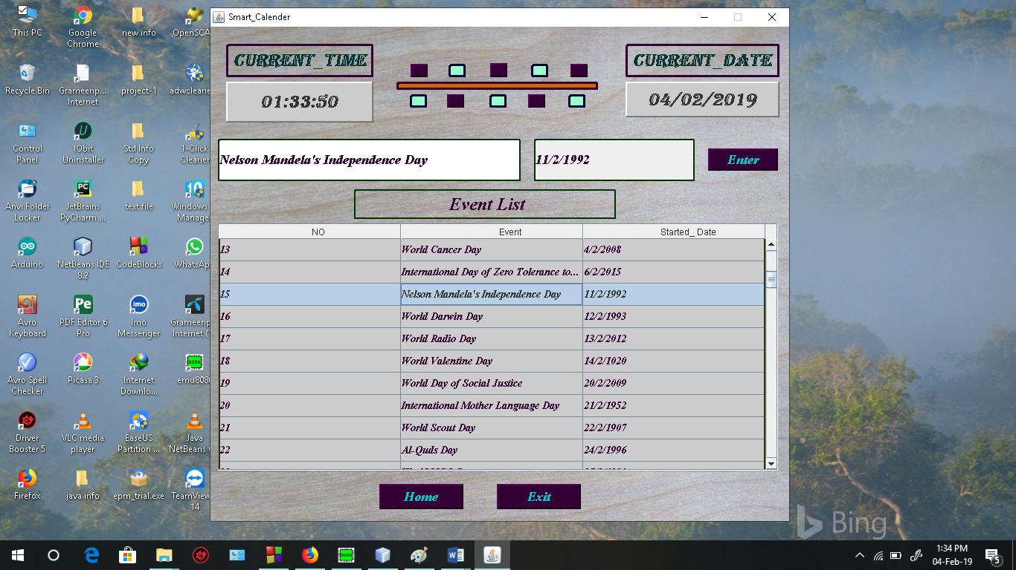

**\*\*\*( welcome/Home/choose Event/output)**

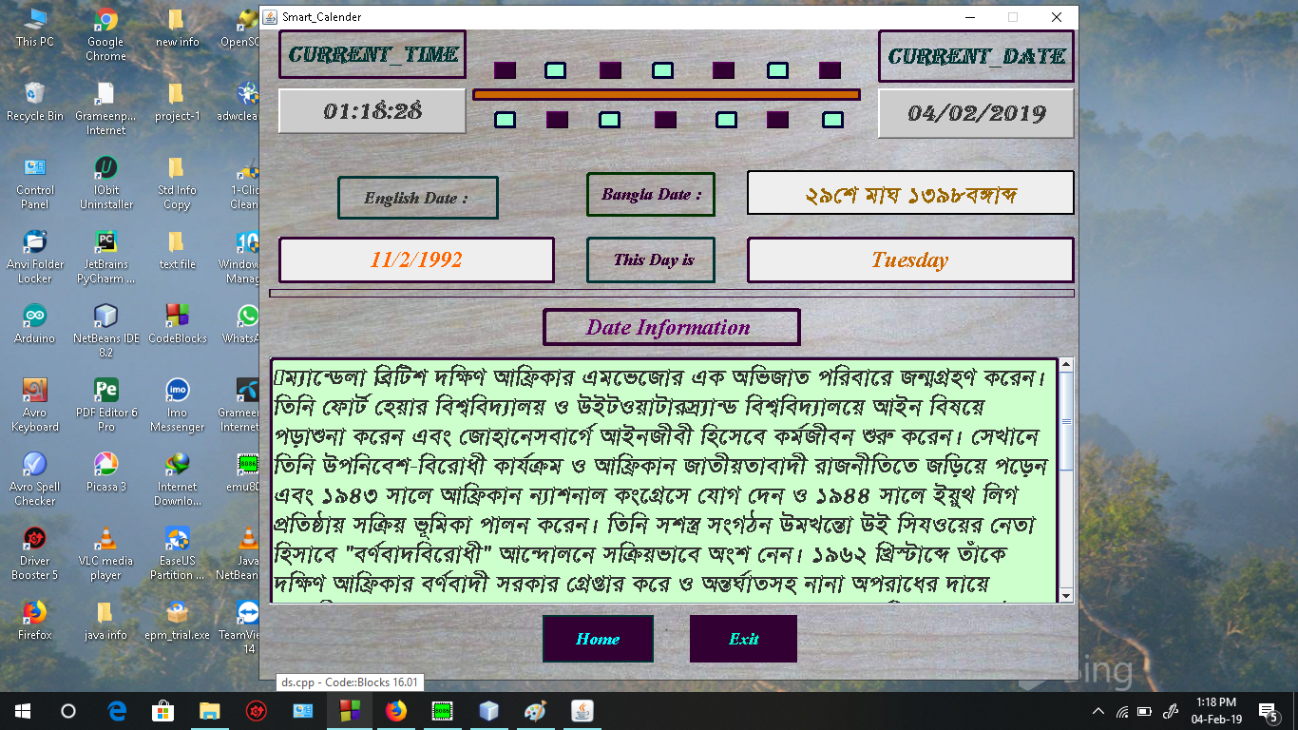

**\*\*\*( welcome/Home/Add Event)**

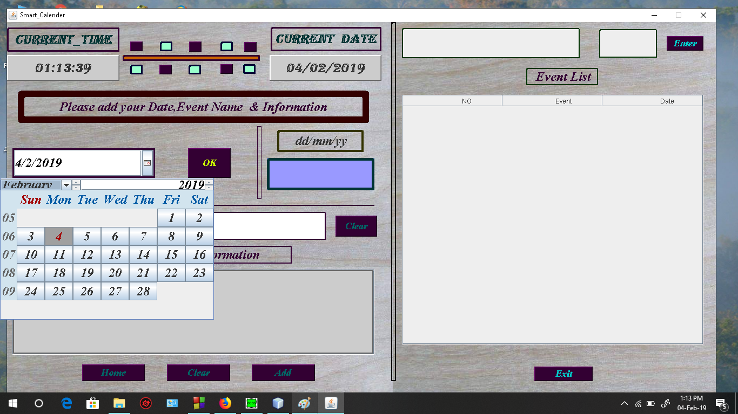

**\*\*\*( welcome/Home/Add Event/output)**

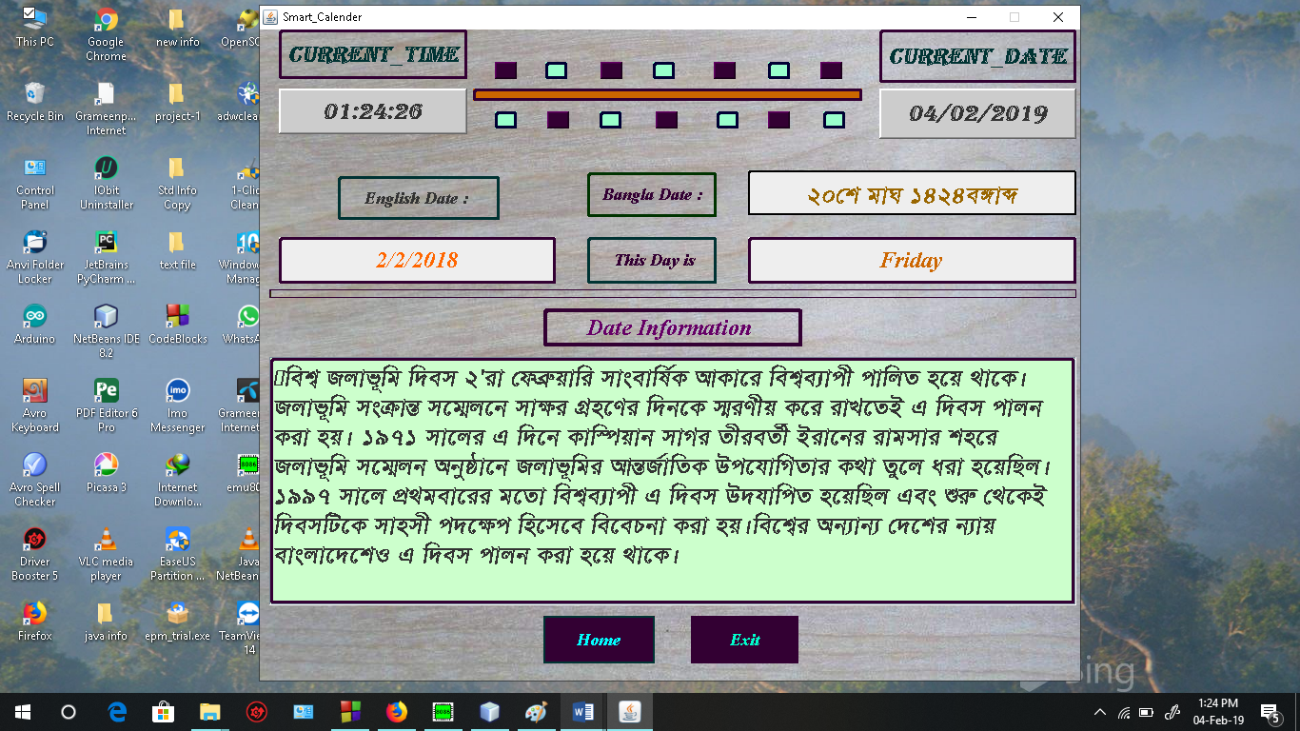

**\*\*\*( welcome/Home/about/about of developers)**

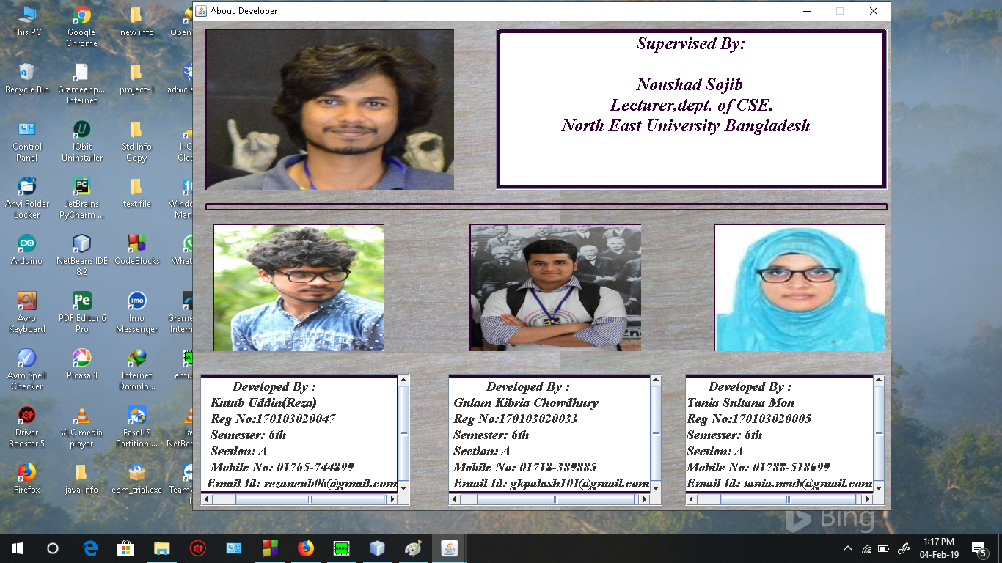

**\*\*\*( welcome/Home/about/about of project)**

